**Oshogatsu Ceremony**

Japan is a country with a strong development in economy, science and technology...and especially Japanese culture can be considered as a traditional value spread not only in the country but also outside the international community. Today, in the process of integration, the overwhelming Western culture has brought a great influence to Japanese culture, making Japan long no longer celebrate the Lunar New Year like other Asian countries. However, the traditional Japanese New Year still retains the typical cultural nuances of the East.

**So what is the Oshogatsu festival?**

Oshogatsu New Year takes place from January 1 to 3. Japanese people prepare for the festival from December 8 to December 12. On these days, every family cleans up, prepares utensils and decorates the house for the new year. January 1 is an important day, marking the beginning of a new year. It is believed that watching the sun rise on this day is the best thing to do to welcome a prosperous, lucky and auspicious new year. Japanese New Year has similarities with Eastern countries, but also has distinctive customs and traditions with many special rituals and has its own style of a country rich in traditions.

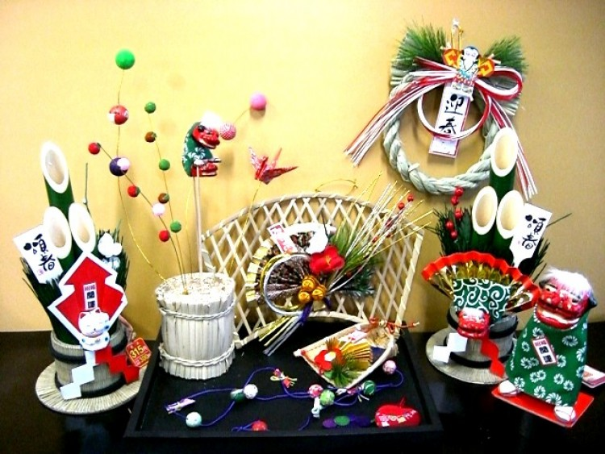

Oshogatsu New Year takes place from January 1 to 3. Japanese people prepare for the festival from December 8 to December 12. On these days, every family cleans up, prepares utensils and decorates the house for the new year. January 1 is an important day, marking the beginning of a new year. It is believed that watching the sun rise on this day is the best thing to do to welcome a prosperous, lucky and auspicious new year. Japanese New Year has similarities with Eastern countries, but also has distinctive customs and traditions with many special rituals and has its own style of a country rich in traditions.

**Hang Shimenawa in front of the house**

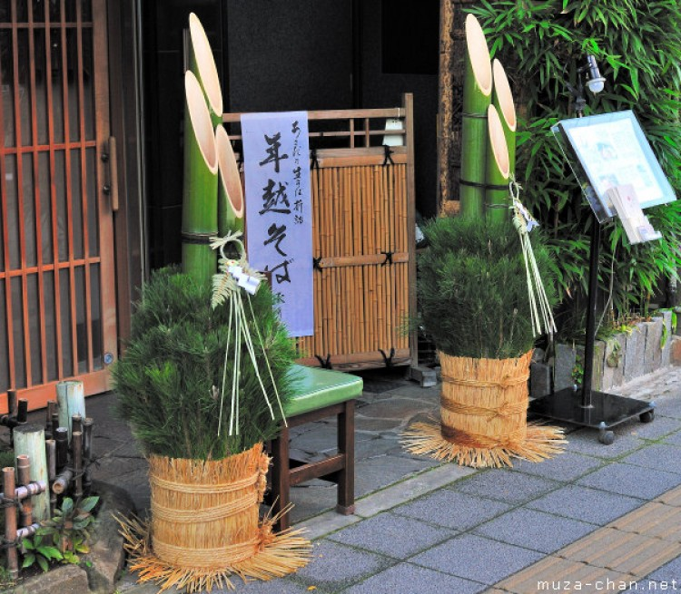

On this occasion, Japanese families will place in front of the gate of their house or company a Kadomatsu tree or tree consisting of pine branches arranged in beveled fresh bamboo tubes. The Japanese believe that bamboo is a ladder to welcome the New Year god, and pine brings luck and longevity. In addition, other items such as ropes braided with dry grass, white strips of paper are also used to decorate, symbolizing the wishes of the Japanese in the new year. In addition, the Japanese also hang Shimekazari charms on Oshogatsu day with the meaning of keeping evil spirits out of the house.

Legend has it that the god Toshigamisama will descend to earth and take refuge in this pine tree. In the past, people used to build pine trees on December 13, which was the beginning of the preparations to welcome Tet. As recently as the 27th or 28th, people avoid erecting pine trees on the 29th and New Year's Eve. On the door frames of many Japanese families are decorated with items such as white leaf knitwear, tangerines, grass braided rope, white paper strips. Tung symbolizes forever young and never old; orange tangerine symbolizes eternal prosperity; grass braided ropes are hung at the shrine or place of worship, offering to the gods for fortune; white leaves indicate spotless chastity; The white strip of paper means cleansing stains and warding off evil spirits.

**Traditional Oshogatsu Day Activities**

Like the traditional New Year in Vietnam, on Oshogatsu days, the Japanese also eat New Year's Eve dinner, write postcards, give lucky money to children and go to pagodas... To celebrate Oshogatsu day, they prepare by cleaning the toilets. Clean houses with the concept of washing away the bad luck of the old year, welcoming the best of the new year. On the last day of the old year, the Japanese will eat a year-end meal together with a large number of family members. Meals are carefully and thoughtfully prepared with traditional dishes made from grains, fish and seafood. During the meal, everyone will talk and share their plans for the new year with a warm and happy atmosphere.

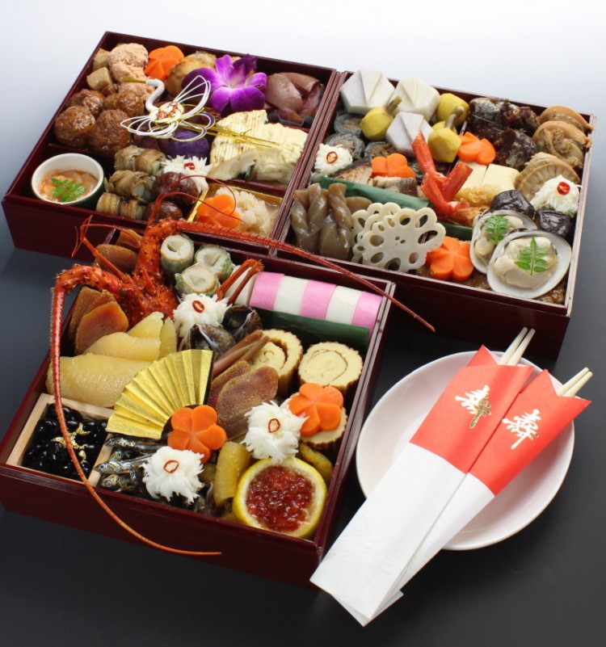

There is a special meal called Osechi Ryori, which is usually prepared before the end of the old year and is eaten in the new year. A variety of foods are included in this meal: seafood, thinly sliced ​​vegetables, boiled beans and more. Each dish is presented in a box called Jubako.The reason to use these boxes is that the food will be more beautifully presented and used to the fullest. Each of these dishes is not mixed with other dishes and symbolizes a good fortune in the future such as health, happiness, good harvest, longevity and abundance in life.

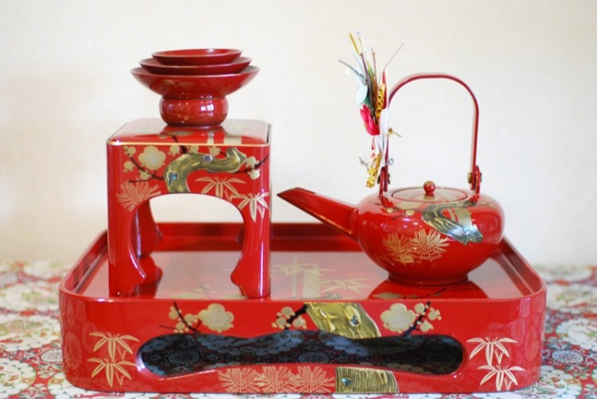

Otoso is a type of alcohol used in osechi meals. This is an herb made from Japanese rice wine. The Japanese believe that drinking Otoso will keep them away from the temptations of the devil. Usually, the Japanese will drink this wine before eating osechi dishes.